**Massachusetts Emergency Management Agency**

**MASSACHUSETTS EMERGENCY MANAGEMENT AGENCY**

**SITUATIONAL AWARENESS STATEMENT**

**January 29, 2019  7:30 AM**

**Re:  Precipitation (Snow, Sleet, Rain) Followed by Extreme Cold Starting Tuesday Afternoon**

**Situation**

The National Weather Service is forecasting precipitation to move into the state today from west to east, starting in the west late this morning or early afternoon, and reaching the east and overspreading the whole state late this afternoon or early this evening.  South of the Providence to Boston line, the precipitation may start as snow but will quickly transition to rain.  To the north of the Massachusetts Turnpike and Rte. 128, the precipitation will be all snow.  The precipitation will end early Wednesday morning, although some areas may experience snow squalls Wednesday afternoon.  Winds may also be strong for a period Wednesday afternoon and evening.  Additionally, temperatures will plummet Wednesday afternoon into Thursday with wind chills temperatures well below zero.

Please see the forecast information and graphics below from the National Weather Service for likely snowfall amounts and wind chill temperatures.

**From the National Weather Service (text in blue):**

**Accumulating Snow late today into tonight:**

* Precipitation overspreads western MA northern CT between 3 and 6 pm this evening, reaching eastern MA/RI after 6 or 7 pm.
* Precipitation type mainly rain along and southeast of a Boston to Providence, to Hartford line after a brief period of snow possible at the onset. Any snow accumulations generally less than 1 inch.
* Mainly snow expected northwest of a Bradley CT, to Worcester MA, to Bedford MA line.  Snow accumulations of 2 to 5 inches anticipated, except  4 to 8 inches in the Berkshires.
* Precipitation ends from west to east between 2 and 5 am Wednesday morning. Locations that change to rain may see precipitation end as a brief period of snow, mainly across northern CT and interior MA.
* Dry weather anticipated for the Wednesday morning commute, but untreated roads across the interior may remain slippery.

**Localized Snow Squalls/Brief Strong to Damaging Wind Gusts Wednesday Afternoon and Evening:**

* Scattered snow squalls anticipated between 3 and 7 pm Wednesday evening.   These squalls may contain briefly very heavy snow, strong winds,  near white-out conditions, and hazardous travel for the Wed evening commute.
* Brief 35 to 55 mph wind gusts possible Wednesday afternoon and evening in most locations and between 50 and 60 mph across the Cape/Islands.
* High Wind Watch posted for the Cape and Islands.  Wind Advisories may eventually be needed elsewhere.

**Bitterly Cold Wind Chills Late Wednesday night into Thursday Morning:**

* Wind chills drop  to between 10 and 25 below zero late Wednesday night into Thursday morning.
* Wind Chill Advisories will likely be needed for a good portion of the region with possible Wind Chill Warnings for portion of the higher terrain of Massachusetts.

**Marine Headlines:**

* Gale and Storm Watches hoisted for all waters Wednesday afternoon and evening for a period of 40 to 50 knot wind gusts.
* Moderate to heavy freezing spray expected Wednesday night into Thursday night across the open waters

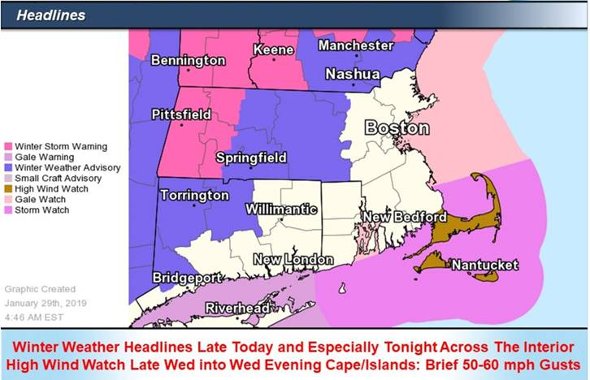

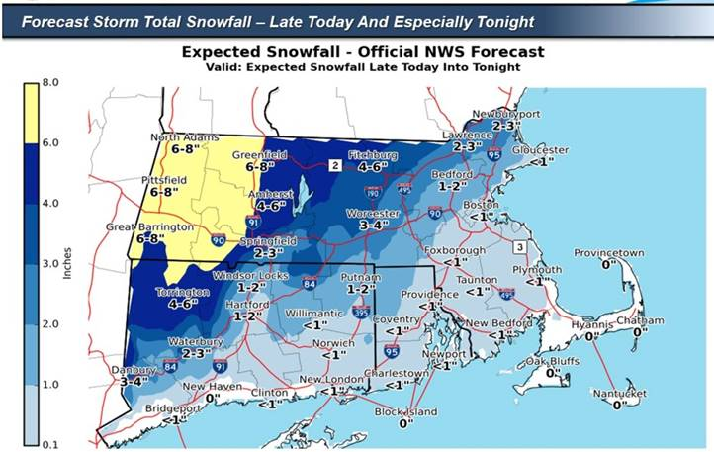

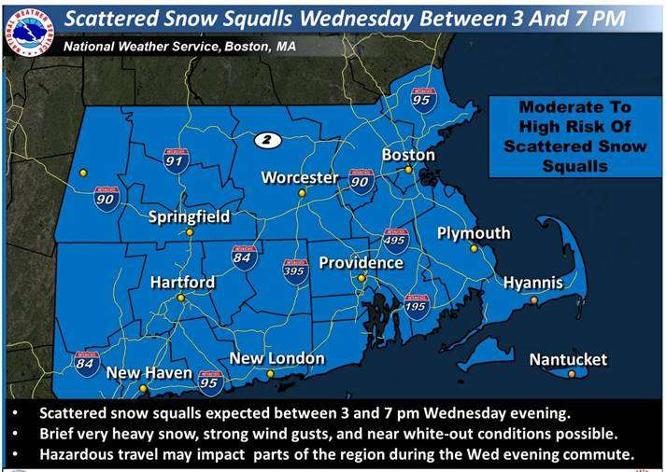

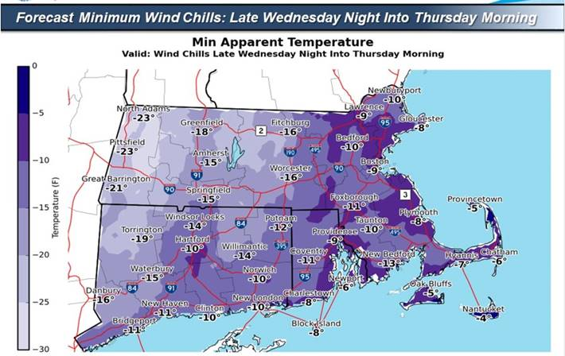

**MEMA Operations**

The State Emergency Operations Center (SEOC) at MEMA Headquarters in Framingham is currently operating at Level 1 (Steady State Monitoring).  MEMA will continue to monitor the forecast and will disseminate Situational Awareness Statements as necessary.

**Preparedness and Safety Information**

* Safety and preparedness tips for extreme cold:   
  <http://www.mass.gov/index.php/service-details/extreme-cold-safety-tips>
* Winter storm preparedness and safety information:   
  <http://www.mass.gov/index.php/service-details/winter-storm-safety-tips>
* Safe winter driving tips:   
  <https://www.mass.gov/service-details/safe-winter-driving-tips>
* Winter safety tips for pets:  
  <https://www.mass.gov/service-details/winter-pet-safety-tips>
* Power outage preparedness and safety information:   
  <http://www.mass.gov/index.php/service-details/power-outage-safety-tips>

·      **Stay Informed:**

Utilize *Massachusetts Alerts* to receive emergency notifications and information from the Massachusetts Emergency Management Agency and the National Weather Service.  *Massachusetts Alerts* is a free app that is available for Android and iPhones. To learn more about *Massachusetts Alerts*, and for information on how to download the free app onto your smartphone, visit: <http://www.mass.gov/service-details/massachusetts-alerts-smartphone-app>.

Utilize MEMA’s real-time power outage viewer to stay informed about current power outages in your community and region, and across the state, including information from utility companies about restoration times: <http://mema.mapsonline.net/public.html>

Utilize MEMA’s live weather radar and forecasting tools: <http://www.mass.gov/map-resources>

**Online Resources:**For additional information and resources, visit:  
Massachusetts Emergency Management Agency at [www.mass.gov/mema](http://www.mass.gov/mema)  
MEMA's Facebook page: <http://www.facebook.com/MassachusettsEMA>  
MEMA Twitter: [@MassEMA](http://twitter.com/massema)  
Federal Emergency Management Agency at [www.fema.gov](http://www.fema.gov)  
National Weather Service/Taunton at [www.weather.gov/boston](http://www.weather.gov/boston)  
National Weather Service/Albany, NY at [www.weather.gov/albany](http://www.weather.gov/albany)  
National Weather Service Weather Prediction Center: <http://www.wpc.ncep.noaa.gov>  
National Weather Service Storm Prediction Center:  <http://www.spc.noaa.gov/>  
Mass211 at [www.mass211.org](http://www.mass211.org)