**Wednesday 7 am – 10 am**

**4 pm – 7 pm**

**Saturday 8 am – 2 pm**

**Sunday 8 am – noon**

***Closed all major holidays***

Residents are encouraged to use the Second Hand Shed at the Transfer Station. Items in good condition may be left in the Shed for another resident to take/reuse. The Attendant has the authority to determine if an item is not appropriate. Clothes and material items are forbidden at the Shed, as it attracts rodents. These types of items can be deposited in the Salvation Army box.

***The Town of Rowe expects residents using the transfer station to be considerate to the attendant and other users of the facility.***

For information about regional waste, recycling, composting, and hazardous waste programs contact the Franklin County Solid Waste District at 772-2438. MA relay for hearing impaired: 711 or 800-439-2370 (TTY/TDD).

FranklinCountyWasteDistrict.org

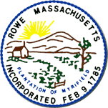

**Rowe Refuse Gardens**

**Policies ~ Fees ~ Hours**

87 Zoar Road

Rowe, MA 01367

(413) 339-0216

July 2025

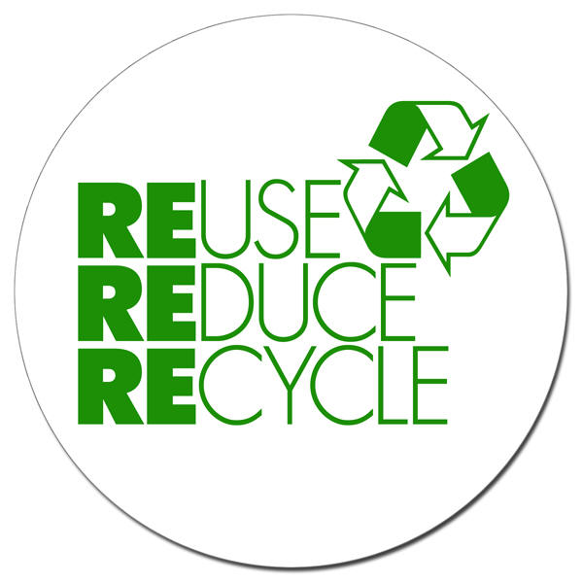

**TRASH BAG STICKERS**

**Affix one sticker to the secured neck of the bag. Maximum capacity 33-gallon bag or 25 pounds. One sticker can be used for *two* 16-gallon kitchen bags.**

**At the beginning of the fiscal year, each household can purchase for $25 a yearly dump tag, which includes 52 trash bag stickers. Additional stickers can be purchased at the Town Hall: One sheet (4 stickers) $4 or Seven sheets (28 stickers) $25.**

Transfer Station Attendants have the right to refuse any item deemed unacceptable or requires additional stickers for overweight or overfilled trash bags. The Board of Health may refuse access to anyone not abiding by rules and regulations.

**The bulky waste bin is for larger household items. Larger loads are limited to an 8 foot pickup bed and limited to once a month. Attendants have the right to refuse any loads which would “over-fill” the bin, limiting use to other residents.**

# Hours of Operation

#### **ROWE RECYCLES!**

It is important that everyone do their part to recycle. **Recycling is required and mandatory** in the Commonwealth of Massachusetts (310CMR19.017) and in the Town of Rowe. Most types of glass, metal, plastic, paper, and cardboard are prohibited from the trash and must be recycled.

**METAL:** aluminum, tin/steel cans and lids and aluminum foil (labels ok)

#### **PAPER:** All paper and cardboard must be clean & dry. Please break down **before** you arrive at the transfer station; junk mail (plastic windows okay); Boxboard (shoe, cereal & cracker boxes, etc. – remove plastic liners); newspaper inserts, magazines, catalogs, paper bags, white and colored office/computer paper, corrugated cardboard (remove packing peanuts, packing pillows, Styrofoam blocks, etc.); paperbacks and phone books; pizza boxes (only portions not contaminated by food or grease); gift wrap (no metallic or glitter); gift bags, cards.

#### **NO** boxes that contain refrigerated or frozen items - including beer boxes or holders. These items are **NOT** recyclable as they contain plastic fibers to keep them from breaking down when wet.

NO soda or beer holders/cartons

NO waxed paper or waxed cardboard

NO egg cartons

#### **GLASS / PLASTIC:**

Recycle clear, brown, and green glass bottles/jars. Recycle most plastic containers less than 2.5 gallons -- labels, lids, neck rings, caps, etc. are okay but only if attached to container; milk and juice cartons (tent top), drink boxes (remove straws & caps, flatten); plastic bottles, jars, clamshells and tubs (remove pumps). Labels and detergent spouts may be left on; health and beauty aid products are okay. See a complete list at franklincountywastedistrict.org/recycle.html.

NO light bulbs, window or auto glass, dishes, glasses, Pyrex, ceramics, broken glass, or black plastic

NO paint or other metal objects

NO plastic bags, containers over 2.5 gallons, motor oil jugs, chemical or Styrofoam containers or flower pots.

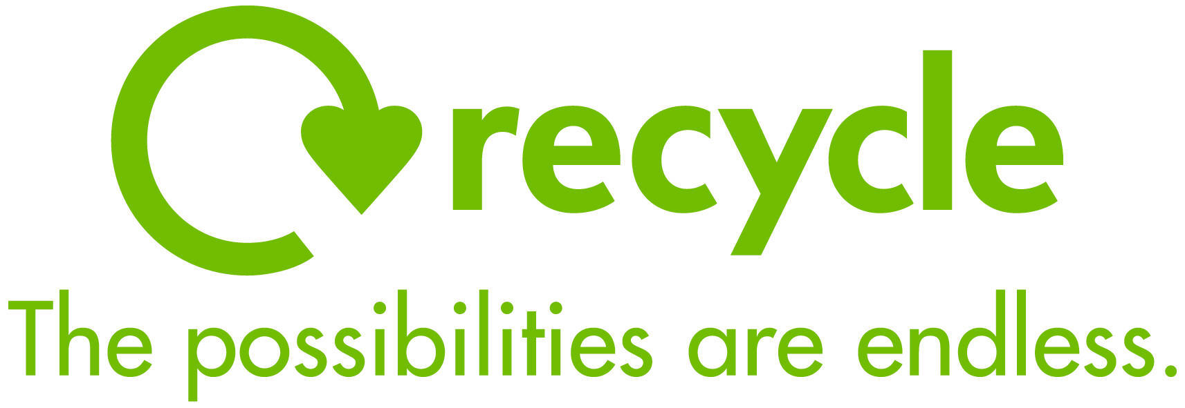

DO **NOT** PUT THESE ITEMS IN THE RECYCLING CONTAINERS:

1. Plastic bags
2. Flower pots
3. Hoses, strings of lights, rope
4. Sharps (needles/lancets)
5. Food waste
6. Hazardous waste (motor oil

jugs, paint cans, pool chemical

containers)

1. Styrofoam cups, trays,

packing peanuts, blocks

1. Plastic cups
2. Light bulbs
3. Pots, pans, utensils
4. Ceramic or plastic dishes,

cups, bowls

1. Electronics

***Please note:*** *Mattresses are no longer accepted in Rowe. If you need to dispose of a mattress, it may be brought to the Colrain Transfer Station at 7 Charlemont Road, Colrain for a fee of $35.*

### Dirty Dozen

### Most Unwanted in Recycling Bins